 October 11, 2020

Dr. Jenahvive Morgan

College of Engineering

Michigan State University

219 Wilson Road

East Lansing, MI 48825

Dear Dr. Morgan,

Attached is a copy of Section 15, Team 5’s Project #1 Report for EGR 100, Fall 2020.

The report describes the design process for an interactive learning mobile application for young children of the age group 2-7 called ‘Fun Learn’. The methods used to develop the application are discussed below along with the motive behind this project. After the preparation of the final design as described below, the functionality of the app has been surveyed and analyzed.

The app has been developed through the cloud-based environment MIT App Inventor. Its content draws on the concepts of the alphabet, mathematics, shapes and colors. The final design was shared with a small test group of children. After a week, the parents of these children were surveyed about the application and the responses revealed positive feedback from most of the respondents, along with suggestions. The parents were surveyed once again after adjustments had been made to the application, still displaying a positive experience.

I hope this report meets your requirements, and any questions will be addressed by email.

Sincerely,

Aman Todi, Craig Stebbing, Kritika Saini, and Vedi Patel

**INTRODUCTION**

The COVID pandemic this year has caused a drastic change in the education system for students of all ages. American Academy of Pediatrics states that 60 million students worldwide are lacking basic educational tools due to the closure of schools [1]. Furthermore, the effect on children of age group 2-7 may be the most pronounced because of the various educational devices that need to be employed to support learning at such a tender age. According to Science Direct, due to the major role technology is playing in schooling in the Post-COVID 19 worlds, it is necessary for children to be proficient at navigating technology [2]. Therefore, cell phone applications are a helpful platform for children to develop their skills using technology.

The ‘Fun Learn’ platform has been developed with this very necessity in mind, to give younger children exposure to fundamental preschool concepts and to allow them to interact with technology simultaneously. It should not be a replacement for traditional educational devices, but as an interactive supplement to a child’s learning process.

**METHODS**

Initially, the scope of the application was discussed. The content of the app was then finalized keeping the target age group in mind. Then the design process was put into action through the MIT App Inventor web application development platform.

The app’s interface has been designed to be simple yet graphic and vibrant to engage the attention of a child. The content has been categorized into the following sections - Alphabet, Mathematics, Shapes, and Colors, each integrated with audio and visual aids. The homepage of the application is shown in Figure 1 along with the buttons for these sections.

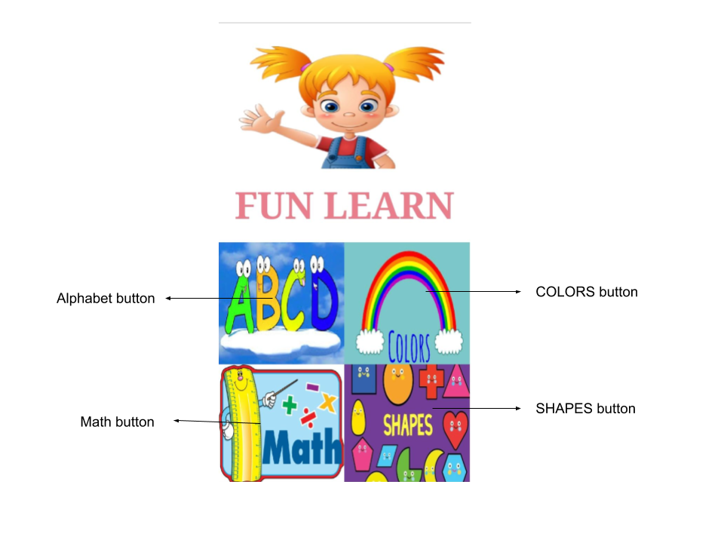

**Figure 1**: Home screen of the application

The app is programmed through blocks within the MIT App Inventor. It supports multiple screens and each screen has a unique set of code to implement various functions and animations.

Some of the notable tools supported by the app development environment that came in handy while developing the app are TextToSpeech, Notifier, Clock, Canvas and ImageSprite. A portion of the Blocks code for the shapes section is shown in Figure 2. It utilizes many of these tools with the help of functions. The Dragged function enables the user to play around with a shape while the Heading, Interval and Speed function make sure that the shape always comes back up. Figure 2 in specific, shows the blocks required to create the initial audio when opening the shapes section along with setting the sizes of each shape’s image to proportional to screen, while making sure only one shape image is visible at a time.

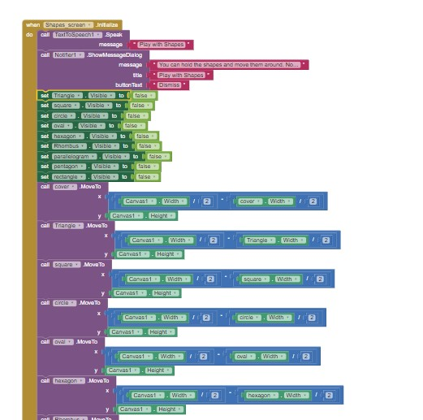

**Figure 2:** Blocks programming of Shapes screen

The Figure below includes images of other categories within the app. The Alphabet screen shown on the left in Figure 3 pronounces the clicked letter along with an object whose name starts with it. The Colors screen works similarly by communicating the name of the clicked color. The Math Quiz is a subsection of Math which allows the child to practice basic arithmetic operations. A calculator with these basic operations is also included in the Math section to familiarize children with one.

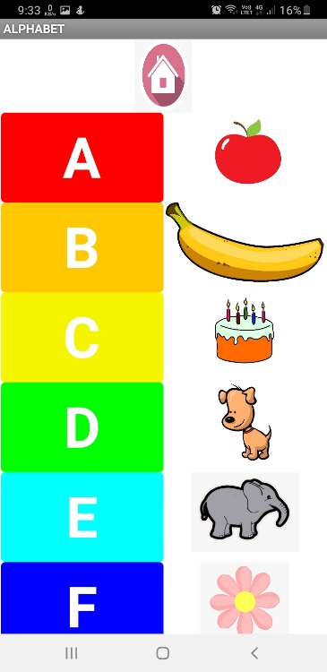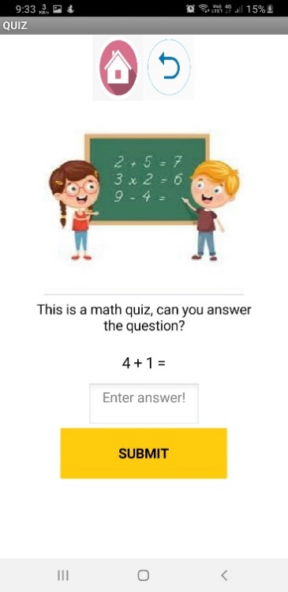

**Figure 3:** Alphabet screen on the left and Math Quiz on the right

Once the final design of the app was ready, it was shared with a test group of 10 children. After a week, the parents of these children were asked to communicate their child’s experience with the app through a survey comprising specific questions. When all the surveyors had given their feedback, the standard deviation and mean of the data were calculated with Equation 1 and Equation 2 respectively.

$σ=\sqrt{\frac{∑{\left(x_{i}-μ\right)}^{2}}{N}}$ (1)

Mean = $\frac{\sum{x_{i}}}{n}$ (2)

The initial survey revealed that some sections of the app were not interactive enough and the animation lacked smoothness. Following this feedback, many parts of the app were enhanced to make the interaction smoother and more enjoyable for children. Audio clues were added to each section using the TextToSpeech tool in order to help young kids navigate the app more easily. For instance, the Math Quiz was redesigned to not only display the question but also pronounce it. A similar change was made to Shapes, Math Calculator, and other notifications within the application. The home screen saw the addition of an animation created using the Canvas, ImageSprite and Clock tools. A welcome audio was added along with the animation which further directs the user to a newly added voice tutorial of the app. The animation in the shape section was also made smoother by adjusting the ‘interval’ and ‘speed’ of the clock enabling the animation. After the changes were made, a second survey was sent to the same recipients and analyzed in the same manner as the first.

**RESULTS**

The survey included the following questions - (i) time spent on the app during a single use,

(ii) number of times the app was used in the week, and (iii) likelihood of using the app again rated on a scale from 1-5. The responses of the 10 respondents can be seen below in Table 1.

**Table 1**: Initial survey responses

|  |  |  |  |
| --- | --- | --- | --- |
| Respondent No | Usage time for one visit | Times used per week | Possibility of future use (1-5) |
| 1 | 16 | 7 | 4 |
| 2 | 12 | 8 | 5 |
| 3 | 15 | 6 | 3 |
| 4 | 10 | 2 | 4 |
| 5 | 10 | 5 | 3 |
| 6 | 10 | 4 | 4 |
| 7 | 13 | 3 | 3 |
| 8 | 25 | 2 | 4 |
| 9 | 11 | 3 | 3 |
| 10 | 13 | 4 | 4 |
| Mean | 13.5 | 4.4 | 3.7 |
| Standard Dev. | 4.6 | 2.1 |  |

As per the initial survey (Table 1), the mean time a child spent on the application in one sitting was 13.5 minutes whereas the average number of times the children used the app during the week was 4-5 times. The average likelihood of the children reusing the app was 3.7/5.

**Table 2:** Second Survey responses

|  |  |  |  |
| --- | --- | --- | --- |
| Respondent No | Usage time for one visit | Times used per week | Possibility of future use (1-5) |
| 1 | 15 | 7 | 4 |
| 2 | 12 | 8 | 5 |
| 3 | 15 | 6 | 4 |
| 4 | 11 | 2 | 4 |
| 5 | 12 | 5 | 5 |
| 6 | 10 | 4 | 4 |
| 7 | 13 | 3 | 3 |
| 8 | 25 | 2 | 5 |
| 9 | 13 | 3 | 4 |
| 10 | 15 | 4 | 4 |
| Mean | 14.1 | 4.7 | 4.2 |
| Standard Dev. | 4.2 | 1.9 |  |

The results of the second survey are displayed above in Table 2. As shown, the average time spent on the app in one sitting went up to 14.1 minutes. The number of times the app was used during the week was close to 5 times. While these two data did not show a substantial change after testing the app’s updated version, the likelihood of children using the app in future was recorded at 4.2/5. This datapoint went up by 0.5 or and indicated that the users were 10% more likely to use the app in future.

A side by side comparison of the first and second survey is available in Figure 4 which displays a graph of each respondent’s time spent on the app during a single visit in minutes.



**Figure 4:** Scatter plot: Time spent on the app during one visit

The graph shows mostly an increase and/or no change in usage time per respondent after the app’s updated version was tested.

**CONCLUSION**

Fun Learn app has turned out to be vibrant, interactive and replete with animations. It has demonstrated the ability to attract children and keep their attention for a good amount of time. The application’s desired purpose was to introduce children to technology while simultaneously educating them, which, as seen through the survey results, seems to be achieved.

While the application does not classify as an essential app used every day, it has the potential to become a good supplement for familiarizing small children with digital learning and helping them to adjust to the changes that the world is currently experiencing due to COVID-19.

**REFERENCES**

1. Masonbrink, Abbey R., and Emily Hurley. “Advocating for Children During the COVID-19 School Closures.” *American Academy of Pediatrics*, American Academy of Pediatrics, 1 Sept. 2020, pediatrics.aappublications.org/content/146/3/e20201440.
2. Iivari, Netta, et al. “Digital Transformation of Everyday Life – How COVID-19 Pandemic Transformed the Basic Education of the Young Generation and Why Information Management Research Should Care?” *International Journal of Information Management*, Pergamon, 27 June 2020, [www.sciencedirect.com/science/article/pii/S026840122031026](http://www.sciencedirect.com/science/article/pii/S0268401220310264)4.